### 

Contents

Definition of problem 2

**DATAFLOW IN THE CURRENT SYSTEM.** 3

**PROBLEMS WITH THE CURRENT SYSTEM.** 4

Requirements Specification. 4

AIMS AND OBJECTIVES 5

AIMS 5

OBJECTIVES 5

Consideration of alternative methods. 5

USE OF A SPREADSHEET PACKAGE 5

***Using a different programming language*** 6

**Justification of method of solution.** 6

File design 8

**Suppliers file** 8

Email Address 8

Clients file 8

Cars file 9

Employees file 9

ER diagram 11

Overall Plan. 12

Test plan. 12

Testing and evaluation. 14

EVALUATION OF SYSTEM 15

OPPORTUNITIES FOR FURTHER DEVELOPMENTS 16

# Definition of problem

Impala Car Rental Company is a company which offers car rental services to the public. The company offers a range of vehicles which include sport cars, luxury cars, buses to mention just a few. It is located at number 40 Chiremba road, Hillside, Harare, Zimbabwe.

The car rental system being used impala car rental is currently a manual system. The manager is responsible for the purchasing of new vehicles which are either from the local or international market. When renting a car the one of the two bookkeepers will record the client details and the car details being rented in the rental book. When a client is returning a car the bookkeeper will record the car details as well as the client details.

## **DATAFLOW IN THE CURRENT SYSTEM.**

details

Car supplier

Clients

details Detail

Returning of rented Cars

Car details

Recording of details

Car Selection

T/F Car File

Purchasing

details Car details

Verification

Purchased

Cars

M/F Car File

Valid Details

Renting

T/F Rented Cars

Recording of payments

Manager

Client details

Rental details

T/F Payment file

T/F Client File

Accounted details

## **PROBLEMS WITH THE CURRENT SYSTEM.**

* Lack of security- the manual system is not secure since the books are kept in drawer’s shelves and unauthorised personal can gain access to the files.
* Slowness of the system-The system is slow when dealing with clients as a result clients tend to repel from the company.
* Laborious -Since the workers have to be, consistently move up and down especially when attending to clients.
* Data Inconsistency-Data can be entered twice due to human error also making data unreliable.
* Unavailability on data back-up -Data is kept in books on shelves and they is no any kind of backup.

# Requirements Specification.

#### User

The manager asks for the complete computerisation of the car rental system. The manager has said that he wants a system that will be secure and be able to record all rental transaction by the clients. The system should allow for the viewing of all the cars in the company . The manager also went on and suggested that the new system should be able to automatically do rental calculation which include the tax as well as discount on various vehicle.

#### SOFTWARE

* WORD PROCESSOR – for documenting data
* JAVA- for programming and running the system
* MICROSOSFT WINDOWS e.g. windows 8 – operating system
* DATABASE PACKAGE e.g. SQLite

#### HARDWARE

* Optical mouse [Input device]
* Standard qwerty keyboard [input device]
* AMD E2-1800 processor(CPU) [Processor]
* 2GB RAM [temporary storage device ]
* 64 GB external hard disk [storage device]
* Colour printer [output device]
* 13’ monitor [output device]

# AIMS AND OBJECTIVES

## AIMS

* To design a system that reduces data duplication by linking related attributes in different tables in a database application.
* To design a system that is fast thus saving time.
* The car rental system should be user friendly making use of a graphical user interface.

## OBJECTIVES

* The system should allow for easy adding of new cars into the system
* The system should allow for the adding of clients into the system.
* The system should enable the removal of car form the system if the no longer exists in the company.
* The system should allow for the deletion to clients that are no longer necessary to the company
* The system should be able to display a list of cars that are in the company
* The system must be in a position to validate data so that errors made are detected.
* The system should be secure through the use of the user identification and user authentication.
* The system should be able to make grand total all rental transactions.

# Consideration of alternative methods.

## USE OF A SPREADSHEET PACKAGE

**MERITS**

* Fast in making calculations such as calculation of fines.
* Data can be alternated and updated at every change in the company for example when a new car has been bought.
* It will allow the use of password into the car rental system hence it is secured.
* Is to some degree reducing data duplication since data of all cars available will be in one pool of data.

**DEMERIT**

* The system will be relatively slow.
* Viral attacks become a threat to the car rental company information.
* The car rental spreadsheet system will depends on electrical power so no power, no services.

#### **Using a different programming language (Visual basic and Microsoft access)**

This method entails of developing a new system making use of a different programming language that is Visual Basic programming language.

**MERIT**

* The structure of the Basic Programming Language is very simple, particularly as to the executable code.
* VB is not only a language but primarily an integrated, interactive development environment (IDE).
* The VB-IDE has been highly optimized to support rapid application development (“RAD”). It is particularly easy to develop GUI and to connect them to handler functions provided by the application.
* The graphical user interface of the VB-IDE provides intuitively appealing views for the management of the program structure in the large and the various types of entities (classes, modules, procedures, forms, …).
* VB provides a comprehensive interactive and context-sensitive online help system.
* When editing program texts the “IntelliSense” technology informs you in a little popup window about the types of constructs that may be entered at the current cursor location.
* VB is a component integration language which is attuned to Microsoft’s Component Object Model (“COM”).

**DEMERIT**

* Visual basic is a proprietary programming language written by Microsoft, so programs written in Visual basic cannot, easily, be transferred to other operating systems.
* There are some, fairly minor disadvantages compared with Java. Java has better declaration of arrays – its possible to initialise an array of structures in Java at declaration time; this is impossible in VB.

## **Justification of method of solution.**

The chosen solution is the bespoke software. The software was chosen because it caters for all the car rental company system requirements especially the requirements specified by the manager (user). The bespoke software that has been chosen will use Java and SQlite Database in the new system. This bespoke software will be of benefit to impala car rental company for it will be easy to use since it works in the exact way required by the company, it will result in improved efficiency since it will precisely match the working practices of the company and last but not least it can be customized to integrate information form the existing system e.g. supplies and clients thus it will be possible for it to be used in the future as well.

**Bespoke Software [ JAVA and SQlite DATABASE].**

**Advantages**.

* Reduces redundancy of the car rental company data.
* It results in impala car rental company being paperless thus also reducing the company’s expenditure on stationary.
* It reduces labour enforcement on the car rental company.
* It will allow fast access of car rental data thus saving time.
* The impala car rental data will be sharable.
* The car rental data is secure and is kept in privacy since there is use of passwords and usernames.
* The impala car rental company files can be linked so that information can be obtained from many files at once.
* Makes the car rental data consistent since they are updated on regular basis.
* Makes the car rental company offices tidy since files kept dust and caused health problems.
* Various validation checks can be performed as car rental clients’ data is being entered.

**Disadvantages.**

* It needs electrical power hence if no power no car rental service will be delivered.
* Viruses can corrupt data about the car rental system.
* It requires a computer literate operator hence causes deskilling of the current impala car rental company employees.
* Causes health risks like eyestrains and infertility to the impala car rental company system users.

# File design

## **Suppliers file**

|  |  |  |  |  |
| --- | --- | --- | --- | --- |
| Field Name | Data Type | Field Size | Description | Format |
| Name | String | 256 | Name of supplier company | Upper and lower case |
| Region | String | 256 | Supplier location | Upper and lower case |
| Email Address | Varchar | 256 | Supplier Email | Integer and lower case |
| Supplier number | Integer | 256 | Supplier number in the system | Integer |

## Clients file

|  |  |  |  |  |
| --- | --- | --- | --- | --- |
| **Field** **Name** | **Data** **Type** | **Field Size** | **Description** | **Format** |
| Name | String | 256 | First name of client | Upper and lower case |
| Surname | String | 256 | Last name of client | Upper and lower case |
| ID Number | VarChar | 256 | Client national ID number | Integer, Upper case and lower case |
| Gender | Boolean | 20 | Client’s gender | Male/Female |
| Age | Integer | 256 | Client Age | Integer |
| Email Address | VarChar | 256 | Client’s email address | Integer, Upper case and lower case |
| Username | VarChar | 256 | Client’s username | Integer, Upper case and lower case |
| Password | VarChar | 256 | Client’s Password | Integer, Upper case and lower case |

## Cars file

|  |  |  |  |  |
| --- | --- | --- | --- | --- |
| Field Name | **Data** **Type** | **Field** **Size** | **Description** | **Format** |
| Name | String | 256 | Name of car | Upper and lower case |
| Color | String | 256 | Colour of the car | Upper and lower case |
| Model | VarChar | 256 | Car model | Integer, Upper case and lower case |
| Registration number | VarChar | 256 | Car registration number | Integer, Upper case and lower case |
| Mileage | Integer | 6 | Mileage of the car | Integer |
| Discount | Double | 256 | Discount value of Car | Double |
| Cost | Double | 256 | Rental Cost | Double |

## Employees file

|  |  |  |  |  |
| --- | --- | --- | --- | --- |
| **Field** **Name** | **Data** **Type** | **Field Size** | **Description** | **Format** |
| Name | String | 256 | First name of Employee | Upper and lower case |
| Surname | String | 256 | Last name of Employee | Upper and lower case |
| ID Number | VarChar | 256 | Employee national ID number | Integer, Upper case and lower case |
| Gender | Boolean | 20 | Employee’s gender | Male/Female |
| Age | Integer | 256 | Employee Age | Integer |
| Email Address | VarChar | 256 | Employee’s email address | Integer, Upper case and lower case |
| Username | VarChar | 256 | Employee’s username | Integer, Upper case and lower case |
| Password | VarChar | 256 | Employee’s Password | Integer, Upper case and lower case |
| Post | String | 256 | Employee’s internal position | Upper case and lower case |

# ER diagram

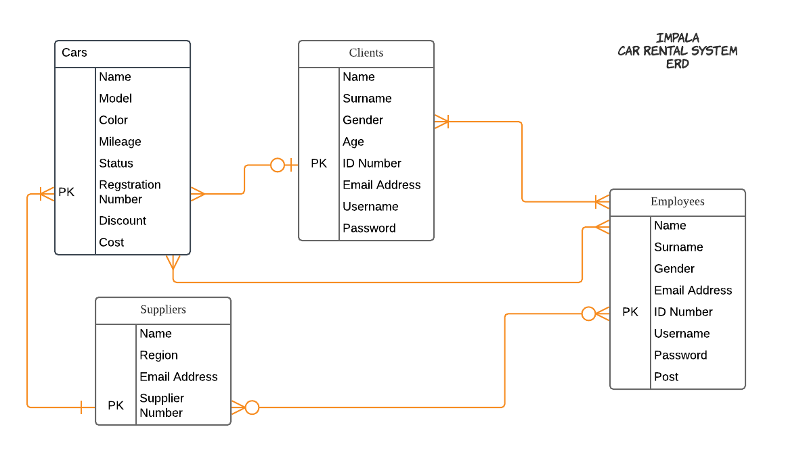

# Overall Plan.

IMPALA CAR RENTAL SYSTEM

LOG-IN PAGE

EMPLOYEES

CLIENTS

EXIT

CORPORATE

EXIT

# Test plan.

EMPLOYEES

CLIENTS

CARS

CLIENTS

EXIT

CARS

EXIT

SUPPLIERS

CARS

**White box testing**

White box testing is the detailed investigation of the internal logic and structure of the code. For White box testing on an application, there is need to possess knowledge on the internal working of the code. The tester needs to have a look inside the source code and find out which unit/chunk of the code is behaving inappropriately. So performing this test will assist in establishing and eliminating all the bugs within the system code thus it making it a very fit testing technique particularly for this system.

**Justification of white box testing.**

In the Impala car rental system white box testing will be appropriate since I would have to test the source code and find out the module that will be having an error for example I would test the cars sub-module under the corporate module so as to establish and eliminate the bugs that will be causing the errors in the system. This is of advantage to Impala car rental company for testing is more thorough, with the possibility of covering most paths and side effects of having the knowledge of the source code is beneficial to thorough testing. There is optimization of code by revealing hidden errors and being able to remove these possible defects. White box testing gives the programmer introspection because developers carefully describe any new implementation and also provides traceability of tests from the source, allowing future changes to the software to be easily captured in changes to the tests. White box tests are easy to automate for the car rental system. White box testing will give clear, Software engineering-based rules for when to stop testing thus adding another advantage of the test plan. White box testing helps in removing the extra lines of code, which can bring in hidden defects. Last but not least the test plan of white box testing will be advantageous as the knowledge of internal coding structure is prerequisite; it becomes very easy to find out which type of input/data can help in testing the application effectively.

# Testing and evaluation.

Testing for standard data.

|  |  |  |  |  |  |
| --- | --- | --- | --- | --- | --- |
| TEST | MODULE | SECTION | TEST DATA | PURPOSE | RESULTS |
| 1 | Log in | Password | scot@47 | Test for standard data | Password accepted! |
| 2 | Rent Out | Clients | $66.00 | Test for standard data | Amount accepted! |
| 3 | Corporate | cars | Land rover | Test for standard data | Car accepted! |
| 4 | Employees | Available cars | BMW 450i | Testing for standard data | Car accepted! |

Testing for extreme data.

|  |  |  |  |  |  |
| --- | --- | --- | --- | --- | --- |
| TEST | MODULE | SECTION | TEST DATA | PURPOSE | RESULTS |
| 1 | Log in | Password | claire@47 | To test extreme data | Password accepted! |
| 2 | Rent Out | Clients | $9999999999999 | To test extreme data | Amount accepted! |
| 3 | Corporate | Cars | Volvo 650 | To test extreme data | Car accepted! |
| 4 | Employees | Clients | Female | To test for extreme data | Amount accepted! |

Testing for abnormal/invalid data.

|  |  |  |  |  |  |
| --- | --- | --- | --- | --- | --- |
| TEST | MODULE | SECTION | TEST DATA | PURPOSE | RESULTS |
| 1 | Log in | Password | Connemara | To test for abnormal data | Invalid Password! |
| 2 | Rent Out | Clients | =[]=-[]] | To test for abnormal data | Amount rejected. |
| 3 | Corporate | Cars | UNCIED | To test for abnormal data | Car rejected. |
| 4 | Employees | Available cars | 6098 | To test for abnormal data | Car rejected. |

# EVALUATION OF SYSTEM

**ACHIEVEMENTS.**

* The Impala car rental System is secure. The system is password and username protected and this password can be changed any time which allows for high levels of security of the password.
* The impala car rental is user friendly. The system is form based coupled with graphical user interface making it easy for the naive users to use. It is also user friendly in the sense that it allows record modifications per user requirement.
* The Impala car rental system is less prone to errors since it allows both verification and validation of data that would be inputted into the system.
* It reduces stationery expenses and reduces junk in the company offices hence reducing paper work.
* The impala car rental system allows data to be sharable through the use of the database application hence reducing data duplication.
* The new car rental system allows back-up storage for it has an indestructible hard disk drive and external hard disk which would be kept away from the car rental company premises.
* The new car rental system reduces human labour because people are relieved from a lot of task for example; no need to walk through the car park looking for available cars.
* The new car rental system is portable hence if non routine data is needed it does not take time to locate it.
* The new impala car rental system allows easy editing of records.

**LIMITATIONS.**

* The impala car rental system is prone to viruses hence information can be lost when they is a viral attack on the system.
* The car rental system is electrical dependent there if they are a power cuts they will be no service.
* The Impala car rental system requires a computer literate operator thus they is need for training to the workers which would be expensive for the car rental company.

# OPPORTUNITIES FOR FURTHER DEVELOPMENTS

The system can be further extended and developed to include the following:

* Create and addition module to cater for cars that are returned with damages.
* The adding of a module that allows for online rental thereby allowing for a car delivery service upon rental.
* External hard disk drive for mass storage which will be kept separately from the company premises so that it will allow for back up in cases of disaster.